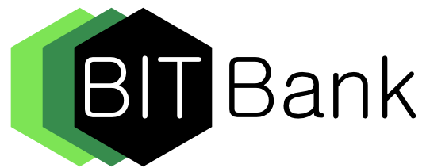

Bitbank shared drive using Github

October 2017

Bitbank S.A.R.L

9, avenue des Hauts-Fourneaux

L-4362 Esch-sur-Alzette (Technoport)

Luxembourg

www.bitbank.lu

Twitter: @BitBankLux

www.facebook.com/BitBankOfficial

Table of Content

Foreword and Executive Summary 4

Short description of Git and Github 4

Tutorial of Github use for Bitbank 5

Login 5

Upload a document to share 5

Pull a document to review 7

Other actions… 7

# Foreword and Executive Summary

This note documents a possible solution for Bitbank shared drive using Github. The advantages are

* Proven service for collaborative work and version control,
* Same tool can be used for development,
* Internet hosting of documents,
* Same level of cyber security as the community of Internet developers using Github.

The issues are.

* Learning curve of collaborative workshare,
* Paid service if the documents are in private repositories.

The purpose of this tutorial is to familiarise the team with the tool using a free but public repository. The final objective is to use Github for Bitbank collaborative work.

# Short description of Git and Github

Git is a tool for software version control created by Linus Torvalds to develop Linux. See <https://en.wikipedia.org/wiki/Git>.

Github is a combination of Git and an Internet hosting service. See <https://en.wikipedia.org/wiki/GitHub>

The concepts that are common to all Version Control Systems (VCS) are:



* Your files are managed by the OS file system, you can always manage them manually,
* Your files and their version descriptors are managed by the VCS, that can delete your files if you delete them from inside the VCS,
* The usual working steps are
* You work on your files with any editor (Excel, PhotoShop, Word, Edit …) in your local computer,
* VCS regroup all files in a project inside a "repository", which is equivalent to a VCS folder,
* You "add" your files to a "staging" area, waiting for "commit",
* "Staged" files are not yet really managed by the VCS,
* "Committed" files are in the VCS and ready to share.
* To make changes without disturbing the "master" repository and carry several parallel modifications that are logically independent, you can
* "branch" a file or set of files into a parallel repository, the main one is called "master"
* "merge" the branch into the "master" when changes are confirmed
* You can create a "remote" of your repository on the Internet, Github is a hosting service for such remotes.
* Other collaborators can "pull" your documents, make changes, and "push" them back to the hosting.

There are other subtle functions to "merge" conflictual changes, "clone" a complete repository …

# Tutorial of Github use for Bitbank

The screen shots of this tutorial are made on a public account open under the following login details. They can be used for exercises.

## Login

Web site: https://github.com/login

User name: kvutien

Password: alp-tank-prudence

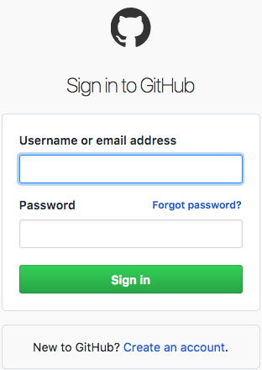 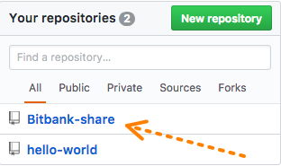

You are presented with the "root" page.

The 2 main tabs that you'll use are "Code" and "Pull requests".

To start with, you are on the tab "Code" and on the "Master" branch.

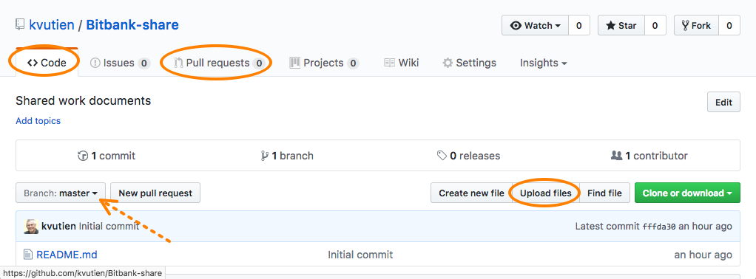

## Upload a document to share

Let's start by uploading to the "master" branch a document to share. Because the repository is public, I'll upload this tutorial file, 20171008 Bitbank shared drive on Github.docx.

From the root page, click on "Upload files".

In the upload page, drag-n-drop the file to upload, one or several files.

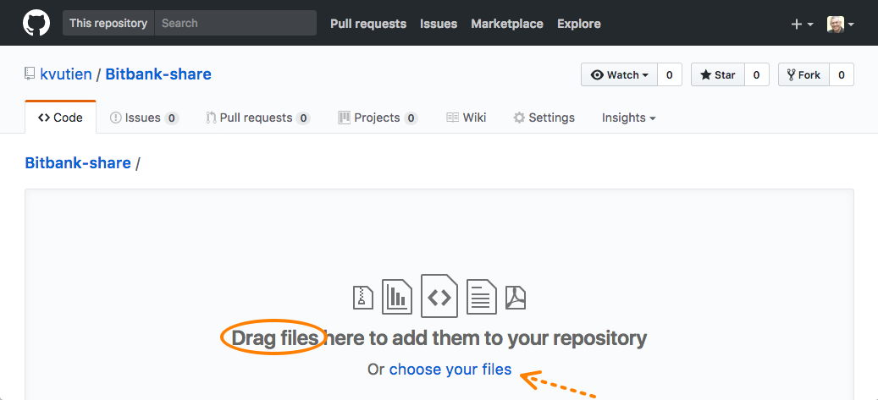

Scroll down, add a short descriptor of the file or the logical group of files, add a long descriptor, check that your are in the branch "master" and click on the green button "Commit changes".

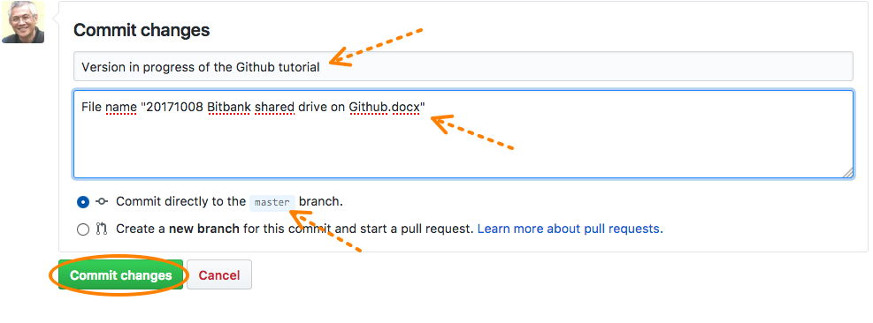

The files are uploaded, committed in Github and you are presented the root page with a new list of files in the repository. You can have details on the new additions with the button "…"

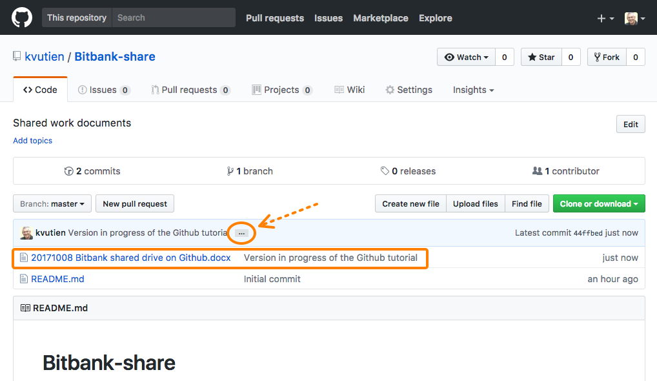

## Pull a document to review

Let's assume now that you are another writer and you want to review and modify the uploaded document.

In the root page above, verify that you are on the branch "master" and click on the name of the file you want to review and modify.

In the page that will be displayed click on the button "Download"

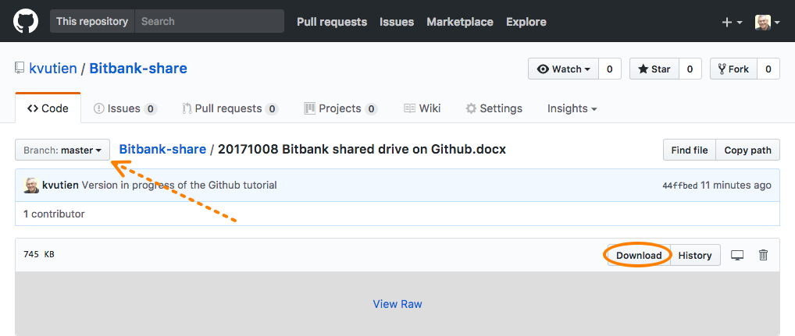

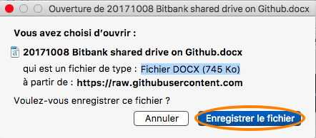

The file is now in your "Downloads" folder, depending on how your OS system parameters. You can now move it somewhere else, rename it and modify it.

Once you are finished you can do as above to upload it. Hint: use the tab "Code".

## Other actions…

You have noticed a trashcan icon to delete a file.

You can also create a "branch", do modifications and "merge" back to "master" but it is not useful to learn at this stage.

You can also make a "pull request", to ask someone to make a pull and comment your work but it is not useful to learn at this stage.